Page 1 - Organization Details

Centre for Rural Education Research and Development Association

Tagline
From Literacy to Lasting Livelihoods

Registration Number
59/1986

Page 2 - Chairman's/Leader's Message
Message from the Chairman/Leader (Word limit: 200-250 words).
As we reflect on another year of transformative community development, I am filled with pride at how our collective efforts are actively reaching the Sustainable Development Goals through grassroots action. This year has been a milestone for women economic empowerment and institutional growth at CENTREREDA.
Our commitment to sustainable livelihoods saw 522 women beneficiaries complete specialized training in agri-entrepreneurship, marketing, and millet value-addition, alongside rigorous sensitization to organic farming methods. To bridge the gap between training and trade, we extended revolving fund support to 36 marginalized farmers, enabling them to launch successful alternative livelihoods.
Parallel to economic progress, we prioritized the holistic wellbeing of our people. Our team conducted mental health awareness sessions for 11,000 rural community members, fostering resilience across the region. In our pursuit of child development, child rights, and child safety, we successfully established three Alternative Education Centres. Looking ahead, we are set to scale this impact by extending these learning centers to 10 new villages.
Our future roadmap is clear: we aim to establish a formidable women’s collective in the Batlagundu block of Dindigul district while expanding our reach through strategic networking opportunities.
These achievements would be impossible without our donors, dedicated field staff, and board members, who remain our strongest pillars of support. Most importantly, we thank the community for their unwavering trust and cooperation. Together, we are building a more equitable and sustainable future.

About the Organization
Organization One-liner :
CENTREREDA empowers rural communities through sustainable organic agriculture, women’s economic empowerment, and holistic child development initiatives to achieve long-term social and environmental resilience.

About Us:
With a legacy spanning four decades, CENTREREDA has remained a steadfast catalyst for community development across the Dindigul, Theni, and Madurai districts. Since 1986, our journey has been defined by a "bottom-to-top" approach, ensuring that rural progress is driven by the very people it serves. We specialize in fostering women economic empowerment through agri-entrepreneurship, millet value addition, and the promotion of sustainable organic farming methods.
Beyond the fields, we are deeply committed to the future of the next generation. Our work in child development, child rights, and child safety provides a protective and nurturing environment for rural youth, most notably through our expanding network of Alternative Education Centres. By integrating mental health awareness with economic support—such as our revolving funds for marginalized farmers—we address the holistic needs of the community.
As we look toward the future, we continue reaching the Sustainable Development Goals by strengthening women’s collectives and expanding our impact through strategic networking. Guided by 40 years of experience and the unwavering trust of our community, CENTREREDA remains dedicated to building a resilient, self-reliant, and equitable rural society.

Vision:
A world where every woman has the economic power.

Mission:
Our mission is to empower marginalized communities, with a special focus on women, children, and farmers, by promoting health, education, and sustainable livelihoods. We achieve this by facilitating access to integrated education, advocating for human rights, and enabling self-sufficiency through sustainable agricultural practices.

Presence :
While rooted in the Dindigul, Theni and Madurai districts for four decades, CENTREREDA has expanded its footprint to serve communities across Tamil Nadu, driving sustainable agriculture, women’s empowerment, and child rights initiatives through a robust statewide network.

Annual Program Highlights

Promotion of minor millets through organic farming practices - CENTREREDA’s initiatives prioritized environmental sustainability through the promotion of climate-resilient millet crop cultivation and diverse alternative livelihood opportunities for marginalized farmers. Value addition trainings empowered 75 women with skills to process traditional grains, while specialized sessions on azolla cultivation and vermi-compost trainings were provided to 42 and 58 beneficiaries respectively. To ensure economic independence, our Green Shop support provides a vital platform to market the products , connecting farmers directly to consumers. Additionally this year, 27 new nutrition gardens improved food security , while a baseline survey of 500 farmers guides our future expansion.

Holistic Economic Empowerment of Marginalized Women Farmers - CENTREREDA is advancing women economic empowerment by transforming subsistence laborers into confident business owners through 45 intensive agri-entrepreneurship trainings. Our program prioritizes environmental sustainability through climate-resilient crop cultivation, water management and value addition trainings for 250 women, incorporating financial and digital literacy to help them market their products effectively. A vital component is our revolving fund support provided to 54 marginalized beneficiaries. This model previously empowered 95% of participants to establish goat rearing enterprises, achieving a 100% return on investment. By combining specialized azolla and vermi-compost techniques with livestock management, we ensure long-term resilience for 2,000 future beneficiaries.

General Mental Health Awareness to Adolescents, Rural Women and Community - CENTREREDA’s commitment to holistic health reached a significant milestone last year, delivering mental health awareness to 11,000 people in Dindigul, Theni, and Madurai. Through targeted trainings for 2,000 adolescents, 8,000 rural women, and 1,000 men, we worked to break the stigma and social barriers that often prevent individuals from seeking help. These sessions emphasized that mental health is as important as physical health, equipping the community with the knowledge to recognize and address psychological needs. This wide-scale sensitization is a crucial step toward building a more supportive and resilient rural society.

Alternative Education Program - Our Alternative Education Programme (AEP) is a grassroots initiative that enrolled 150 village children last year across three pilot locations. This after-school model is powered by dedicated local volunteers and funded through community contributions, ensuring a sustainable impact on child education. The program emphasizes child safety and child nutrition while using interactive methods to enhance problem-solving skills. By providing a protective learning environment, we empower the next generation to thrive. Following this success, we are scaling our reach to 10 additional villages in the upcoming year to foster widespread rural development.

Annual Impact Highlights

Women Economic Empowerment: Provided 45 agri-entrepreneurship trainings to 250 women, focusing on financial and digital literacy for marketing millet-based products. Additionally, revolving fund support was extended to 54 marginalized beneficiaries, enabling successful goat rearing enterprises with a 100% ROI.
Alternative Education (AEP): Enrolled 36 children in after-school programs focused on child safety, nutrition, and problem-solving.
Mental Health: Reached 11,000 individuals across Dindigul, Theni, and Madurai to break stigmas.
Environmental Sustainability: Established 14 new nutrition gardens and promoted climate-resilient millet cultivation.

Team & Impact Table
Team Member List (Name, Designation) - Keep short, max 1 line per member.
Team Name | Designation
- C. Durgadevi | Program Director
- R. Muthammal | Field Staff
- E. Indra Gandhi | Field Staff
- R. Nagamalayan | Field Staff
- R. Karthiga | Field Staff
- A. Bavani | Accountant
- C. Hariharan | Mental Health Advocate
- R. Karthick | Mental Health Advocate

Impact Table:

Impact Number | Detail
11,000 | Individuals reached across Dindigul, Theni, and Madurai for mental health awareness.
522 | Women beneficiaries completed specialized training in agri-entrepreneurship and marketing.
250 | Women provided with intensive training in financial and digital literacy for millet marketing.
36 | Village children enrolled in the Alternative Education Programme (AEP) across three pilot locations.
75 | Women empowered with specific skills to process traditional grains through value addition training.
54 | Marginalized beneficiaries provided with revolving fund support for enterprises like goat rearing.
100% | Return on investment achieved by participants established in goat rearing enterprises.
41 | New nutrition gardens established to improve food security.
100 | Beneficiaries trained in specialized organic techniques, including 42 in azolla and 58 in vermi-compost.

Partners, Donors
Partner/Donor Logos
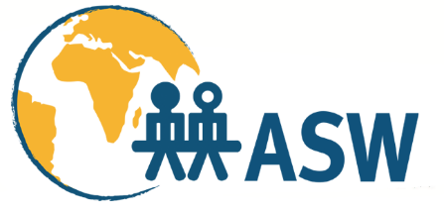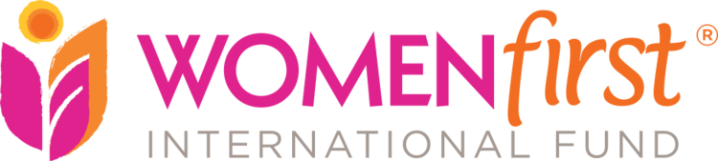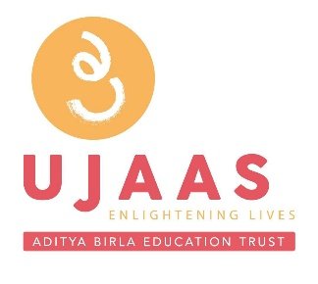

Beneficiary Story:
Interviewer: Field Staff - Mr. Nagamalayan & Mrs. R. Muthammal
Beneficiary: A. Suganthi, 30, Rengappanaykkanpatti, Batlagundu Block, DIndigul District.
Background: Suganthi, a daily wage laborer and mother of two, faced severe hardship after being abandoned by an abusive husband. As the sole provider for her children and mother-in-law, her irregular income from agricultural labor was insufficient to meet basic needs.
CENTREREDA’s Intervention: CENTREREDA intervened through community awareness and skill-building initiatives. They facilitated Suganthi’s enrollment in a professional tailoring program, where she mastered embroidery and blouse stitching. Furthermore, through CENTREREDA’s Investment Grant Revolving Fund, she acquired three goats to diversify her income.
Impact: Today, Suganthi earns approximately ₹6,000 to ₹7,000 monthly. Beyond financial stability, she has mastered SHG management and record-keeping. By overcoming domestic adversity and poverty, Suganthi has transformed from a vulnerable laborer into a self-sufficient entrepreneur and a role model within her village, thanks to CENTREREDA’s holistic support.

Case Study 2: Interviewer: Field Staff - Mrs. E. Indira Gandhi Beneficiary: R. Jeyanthi, 35, Viruveedu
Background: Jeyanthi, a daily wage agricultural laborer and mother of two, initially struggled with financial dependence. Despite her hard work, she lacked the autonomy to manage her own expenses or provide for her family’s future.
CENTREREDA’s Intervention: CENTREREDA catalyzed Jeyanthi’s transformation through multi-faceted skill training. She first established a nutrition garden to secure food and surplus income. CENTREREDA then facilitated advanced training in tailoring, embroidery, and millet-based value addition. To further diversify, they connected her with eco-friendly product training, including cow-dung-based crafts and organic cleaners.
Impact: By marketing millet health mixes and traditional crafts through CENTREREDA’s Green Shop, Jeyanthi now earns an additional ₹6,000 to ₹9,000 monthly. Her journey from a marginalized laborer to a diversified entrepreneur proves that targeted skill development can dismantle the cycle of dependency, creating self-sufficient leaders in rural communities.

Financials:
Yearly Turn Over:
- Year 2022 – 2023 – Rs. 14,43,528.93
- Year 2023 – 2024 – Rs. 19,38,030.00
- Year 2024 – 2025 – Rs. 23,40,735.00

15. Funds Received : (During last year)

No. | Month/Year | Other Donor | Amount (INR)
1. | November 2026 to October 2026 | WomenFirst International Fund - USA | 1307351.89
 |  | Total 2023-2024: | 1227351
2. | April 2025 – March 2026 | Aditya Birla Education Trust Mpower  (1,00,000) | 100000.00
3. | April 2025 - 2026 | ASW, Berlin | 225000.00
 |  | Total 2024-2025: | 1632351.00

Contact Information
Main Address - No:9-1-300, 1st Street, Jeganathapuram, Kodairoad,
Nilakkottai Taluk, Dindigul District, Tamilnadu, India. Pin -624206
Phone - +91 8248557892
Email – centrereda@gmail.com
Website – www.centrereda.org

Annexure 1:
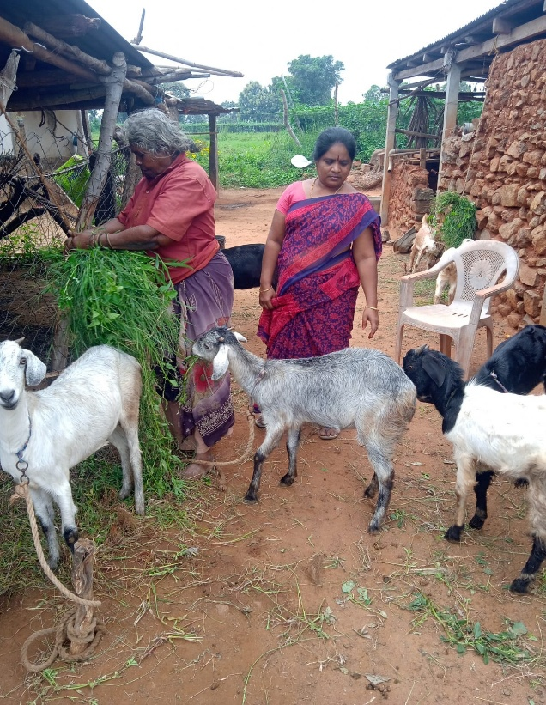
Figure 1 Revolving Support Goat Rearing
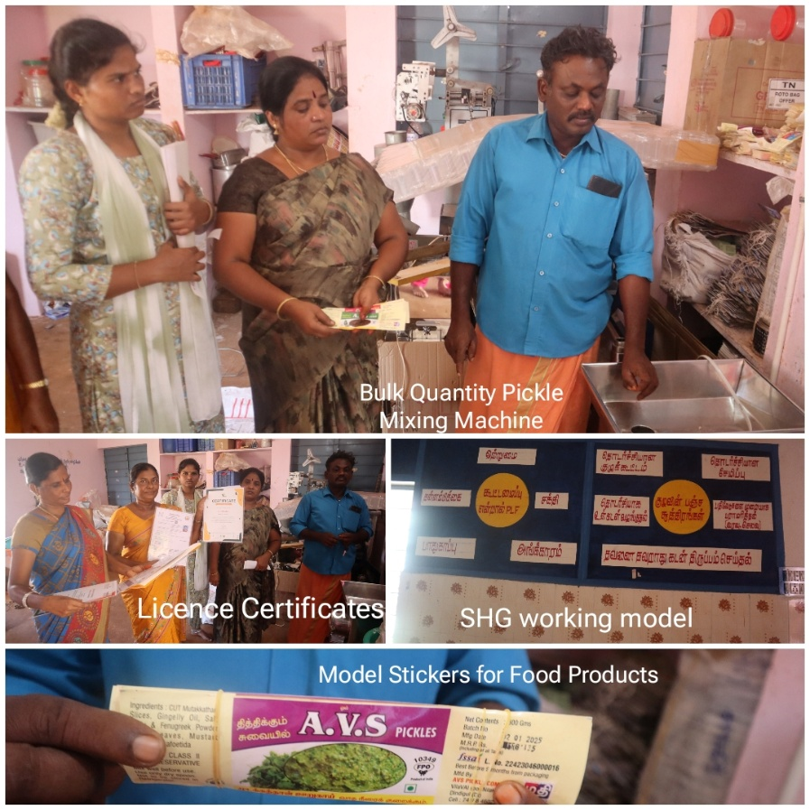
Figure 2 Field Exposure Visit to Ethilodu Panchayat
Figure 3 Training on Climate Smart Agriculture
